Cloud Service Business Plan

1. Product Strategy
2. Product Vision
   * Product Name
   * Target Market: User Profiles / User Goals to be achieved by the product
   * Key Themes: High-level Use Cases
   * Key Value Propositions: Gain Creators and Pain Relievers
   * Key Differentiation: Discriminant value propositions vis-à-vis competitors

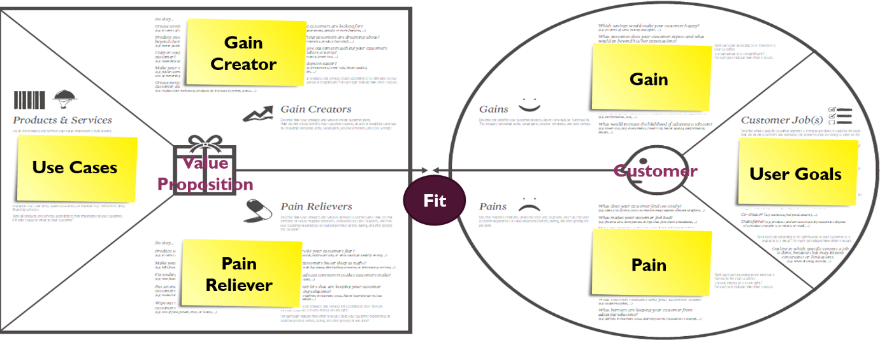

1. Product Roadmap
2. Product Ecosystem
   * Platforms and complementors
3. Competitive Landscape
4. Market and Competition Trends
   * Current demand and future trends in the target market
   * Incumbent competitors and their market shares
   * Technology and application trends
   * Value Migration
   * Barriers to market entry and how you will overcome them (Patents, unique technology, brand recognition, etc.)
   * Any potential substitute in the foreseeable future?
5. Competitive Analysis

|  |  |  |  |
| --- | --- | --- | --- |
| Competitive Product | A | B | C |
| Customer base and market share |  |  |  |
| Customer TCO |  |  |  |
| Customer values |  |  |  |
| Operational and technical capabilities |  |  |  |

1. Competition Strategy
   * Market niche
   * Strategy Canvas
   * Competitive advantage

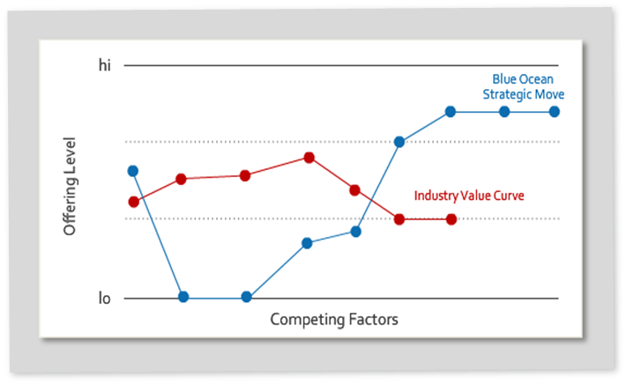

1. Target Market Segmentation
2. Addressable Markets
   * Which geographic regions, generations, vertical industries to target
   * Market size, growth potential and sales forecast
3. Initial Target Customer Organizations or Consumers
   * Where are visionary early adopters who can help you develop a right service?
   * Persona of target customers
4. Marketing Plan
   * How will you develop the market awareness about your service? (Product positioning, Web marketing, advertising, etc.)
   * What is the right price and how will you find paying customers?
5. Product Release Plan
6. Release Epics and Themes

|  |  |  |  |  |
| --- | --- | --- | --- | --- |
| MR ID | Epic | Theme | Competitive Advantage | Value Proposition |
| MR1 |  |  |  |  |
| MR2 |  |  |  |  |
| MR3 |  |  |  |  |
|  |  |  |  |  |
|  |  |  |  |  |

1. Product Positioning

|  |  |  |
| --- | --- | --- |
| PP ID | Audience | Message |
| PP1 | Business users |  |
| PP2 | CFO |  |
| PP3 | CIO |  |

1. Product Development Team Organization
2. Product Release Requirements
3. Functional Requirements (Product Backlog)

|  |  |  |
| --- | --- | --- |
| Use Case ID | UC1 | |
| Use Case Name |  | |
| User Story | As a _____, I want to __________ so that I __________. | |
| Actors |  | |
| Use Case Description |  | |
| Preconditions |  | |
| Postconditions |  | |
| Use Case Scenarios | Normal Flow |  |
| Alternative Flows |  |
| Exceptions |  |
| Includes |  |
| Rules |  |
| Special Req’ts |  |
| Priority |  | |
| Supporting Requirement Models |  | |

1. Non-Functional Requirements
   * Performance and availability requirements
   * Security requirements
   * Compatibility requirements
   * Laws and regulations affecting your product and services
2. Customer Training and Support Requirements
3. Product Technology and Architecture
4. Product and Service Technologies Applied
5. Product and Service Architecture
   * Software architecture of the product
   * Facilities, infrastructure and platforms required for developing the product and service
   * Facilities, infrastructure and platforms required for service operation and management (Self-service contract, service-level agreement, real-time provisioning, service monitoring, service metering, billing, payment, etc.)
6. Business Architecture and Operations Plan
7. Business Architecture

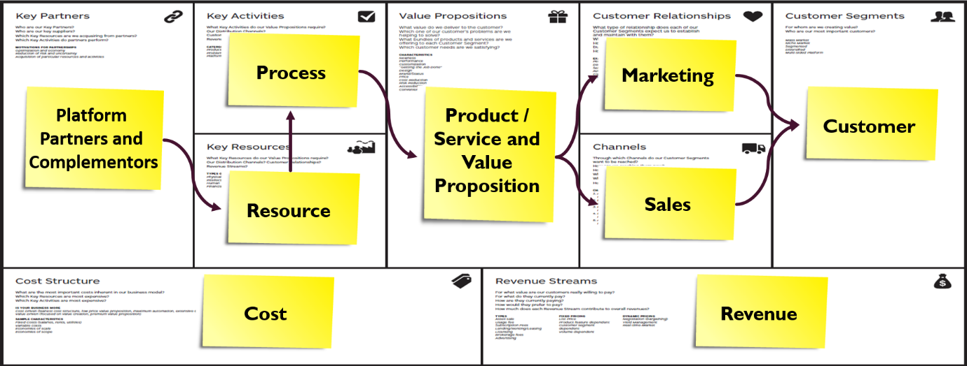

1. Customer, Product and Service Development Process
2. Software Engineering Methods, Tools and Skills Required
3. Preliminary Development Schedule and Budget
4. Organization Plan
5. Company’s Mission, Vision and Core Value
6. Legal Form of Ownership
   * Sole proprietor, partnership, corporation, etc.
7. Professional and Advisory Support
   * Board of directors, advisory board, venture capitalist, attorney, etc.
8. Startup Management Team and Employees
   * Management team members and their expertise
   * Jobs, roles, responsibilities and required skills of employees, and how many to employ for each job/role
   * Essential operational processes and training
9. Startup Funding
   * Bootstrapping, Venture Capital, Angel Fund, Private Equity, Crowdfunding
   * How much will be contributed by each investor to the startup capital and what percent ownership each will have
10. Financial Projections
11. Revenues and Costs
    * Subscription revenues, advertising revenues, professional service revenues
    * Capital expenditures, operational expenses, contingencies
12. Profit and ROI
13. Risk and Consequences

|  |  |  |  |  |  |
| --- | --- | --- | --- | --- | --- |
| Risk ID | Risk Name | Description | Exposure | Probability | Mitigation Options |
| R1 |  |  |  |  |  |
| R2 |  |  |  |  |  |
| R3 |  |  |  |  |  |

Glossary

References

Appendix: Requirement Models